Chapter 4 programming practice

# Program the resource-request algorithm

Given the common.h file to include in your implementation - the resourcerequest.cpp file.

## common.h

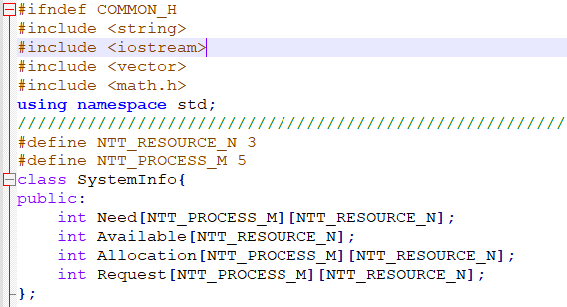

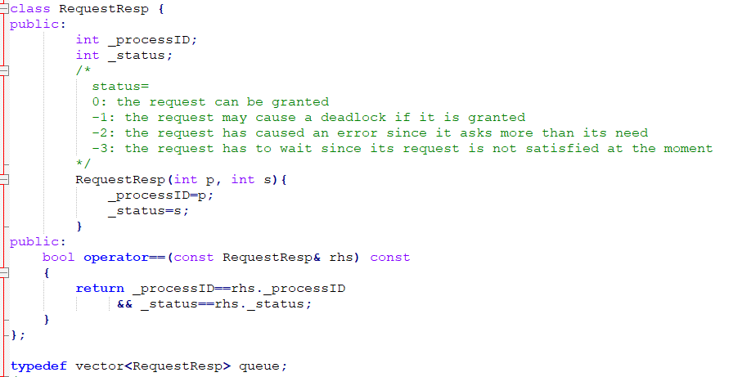

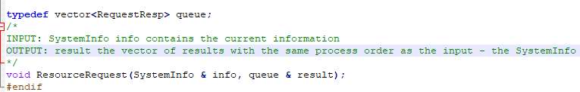

## main.cpp

main.cpp includes the definition of testcase and testcase initialization

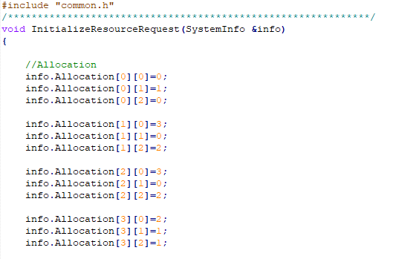

…

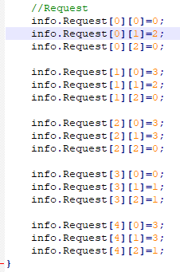

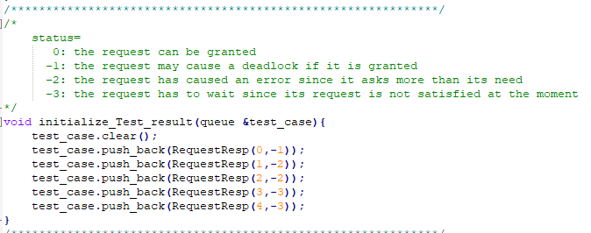

The main function is the test case

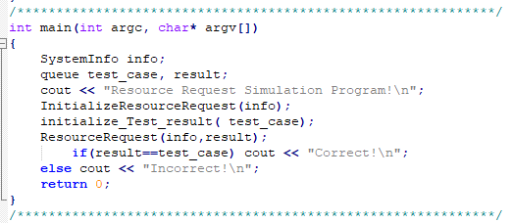

## Makefile

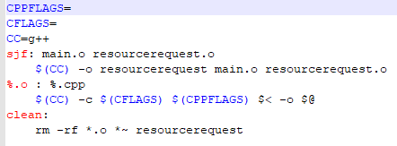

# Problem

Implement your void ResourceRequest(SystemInfo & info, queue & result) in resourcerequest.cpp file